**AWS Security Tools**

* AWS WAF (Web application Firewall): To prevent APIs from DDOS attacks and allow trusted IPs the WAF is enabled at API Gateway level.  
  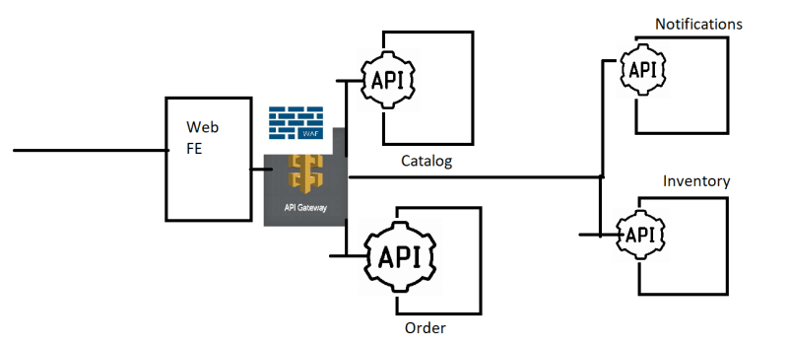
* Enable Protections on the API Endpoints by all the known attacks by using Web ACLs  
  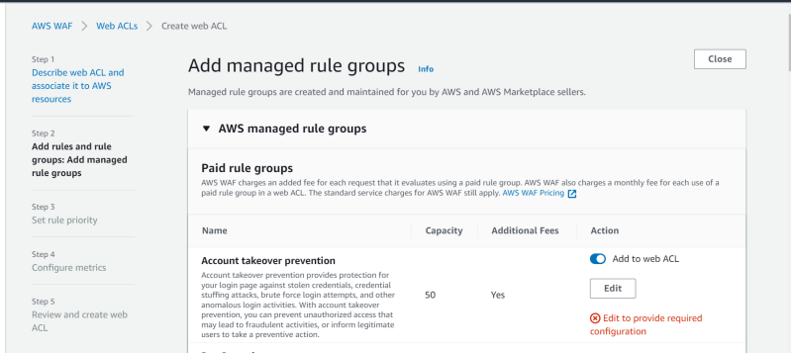

**Microsoft Azure => Microsoft Defender**

* <https://learn.microsoft.com/en-us/azure/defender-for-cloud/defender-for-cloud-introduction> for the official docs.
* Enabling Defender in Azure Subscriptions <https://learn.microsoft.com/en-us/azure/defender-for-cloud/get-started>
* pricing <https://azure.microsoft.com/en-us/pricing/details/defender-for-cloud/>
* WAF Policies:  
  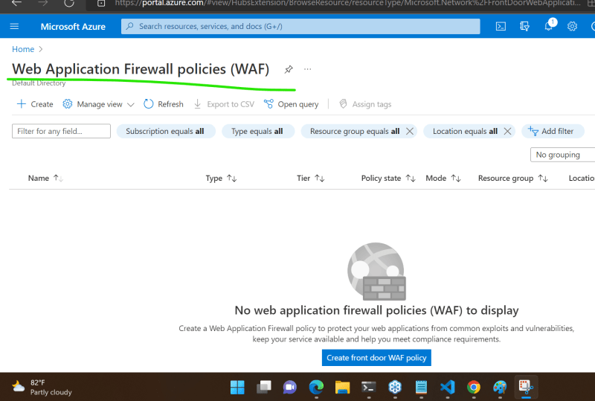  
  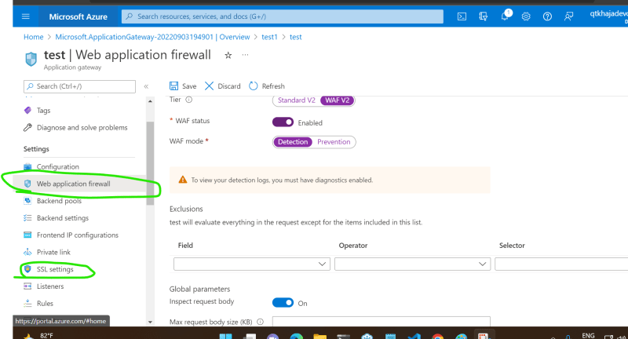

**Fortify Scanning Docs**

* <https://www.microfocus.com/documentation/fortify-static-code/1720/> for the static code analysis tools docs from micro focus